TVRA Wrestling Pre-Season Meeting – 2019

MINUTES ARE IN RED

1. TVRA, WOSSAA, and OFSAA
2. Eligibility Reminders
3. League Meet Schedule
4. Charrette-Michienzi Divisions
5. Tournaments
6. New End-of Season Geris Award
7. Rules and Regulations Update
8. Referee’s update- John Cook
9. Update coaches contact list?
10. Club Wrestling
11. Other business?
12. TVRA, WOSSAA & OFSAA-

Note: Sue Perkins has retired from Provincial and National drawmastering, but is still available for us

The details for TVRA are:

Weigh-ins – Wednesday February 12th @ Clarke Road 3:30 – 5:30 PM (satellite weigh-ins for remote locations)

|  |  |
| --- | --- |
| Ranked Team Numbers for TVDSB | |
| School | Total # of Wrestlers |
| 1. London Central | 31 |
| 1. Saunders | 26 |
| 1. Beal | 26 |
| 1. Clarke Road | 24 |
| 1. Medway | 23 |
| 1. Banting | 22 |
| 1. Lucas | 22 |
| 1. Parkside | 21 |
| 1. Laurier | 18 |
| 1. Dorchester | 12 |
| 1. Central Elgin | 11 |
| 1. CASS | 7 |
| 1. Glendale | 5 |
| 1. Montcalm | 5 |
| 1. Notre Dame | 2 |
| 1. Oakridge | 2 |
| 1. Huron-Park | 1 |
| 1. Gabriel-Dumont | 1 |

TVRA – Thursday, February 13th

TVRA Charrette @ Clarke Road

TVRA Michenzi @ Saunders

Snow Date: Fri Feb 14th

The details for WOSSAA are:

Weigh-ins – Thursday, February 20th @ Banting 3:30 – 5:30 PM (satellite weigh-ins for remote locations)

WOSSAA – Friday, February 21st @ Banting

Snow Date: Mon February 24th

The details for OFSAA are: March 2nd – 4th

Details not available yet, but it is in Sault Ste. Marie

Website: <http://www.ofsaa.on.ca/wrestling/>

2. TVRA Eligibility forms are due before the first competition. They will now be uploaded to the TVRA website. Each coach will get a login to do this, speak to your Athletic Director.

3. League Meet Schedule- Return to Dual Meets

* The Round Robin meets were too cumbersome to host/organize, so we are returning to a dual meet schedule
* As in years past, all schools not included in the schedule can attend any meet they wish; they must contact host schools to confirm a spot
* The 8 largest teams will make up the dual schedule
* Each week has 2 tri meets and 1 dual meet. Tri meets will take place on 2 mats; duals may be on one or two mats
* Start times will be 3:30; host schools can adjust if they wish but must notify Wolff Schweitzer and John Cook, the new head referee, and we must ensure referees are available
* We realize that with the bussing visiting teams may be dropped off several hours before start time; please contact host coach ahead of time so athletes have somewhere to hang out
* Top Catholic team is the 3rd seed in the dual finals this year
* Scoring remains the same at 3 points for both male and female weight classes without a match
* Let us know if you are running your dual on 1 or 2 mats
* Dates and Hosts below are NOT CONFIRMED YET- schedule below now VOID

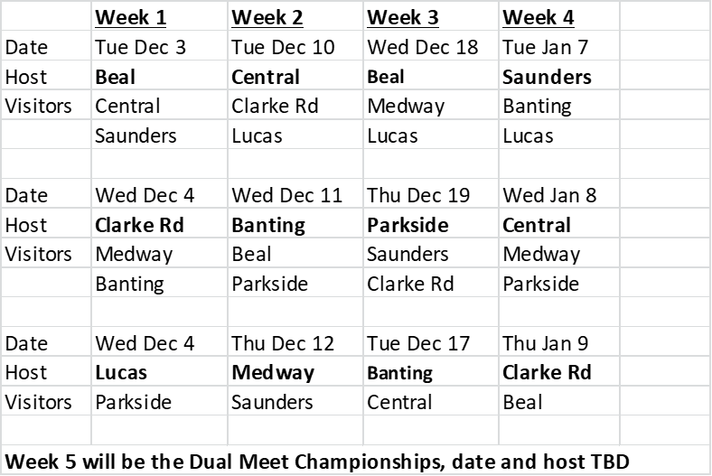

**Clarke Road has proposed the following alternate schedule which would accommodate their United in Sport Day. Everyone okay with making the change? YES, BELOW IS THE FINALIZED SCHEDULE (which I emailed out the evening of Nov 5th)**

|  |  |  |  |  |
| --- | --- | --- | --- | --- |
| **Alternate Schedule (Clarke Road United in Sport)** | | | | |
|  | **Week 1** | **Week 2** | **Week 3** | **Week 4** |
| Date | Tue Dec 3 | Tue Dec 10 | Wed Dec 18 | Tue Jan 7 |
| Host | **Beal** | **Central** | **Beal** | **Saunders** |
| Visitors | Central | Lucas | Medway | Banting |
|  | Saunders | Parkside | Lucas | Lucas |
|  |  |  |  |  |
| Date | Wed Dec 4 | Wed Dec 11 | Tue Dec 17 | Wed Jan 8 |
| Host | **Banting** | **Banting** | **Parkside** | **Central** |
| Visitors | Medway | Beal | Saunders | Medway |
|  | Parkside |  |  |  |
|  |  |  |  |  |
| Date | Wed Dec 4 | Thu Dec 12 | Thu Dec 19 | Thu Jan 9 |
| Host | **Lucas** | **Medway** | **Clarke Rd** | **Clarke Rd** |
| Visitors | Clarke Rd | Saunders | Central | Beal |
|  |  | Clarke Rd | Banting | Parkside |
| **Week 5 will be the Dual Meet Championships, date and host TBD** | | | | |

4. Charrette-Michienzi Divisions

|  |  |  |  |
| --- | --- | --- | --- |
| Team Numbers based on TVRA 2019 | | | |
| Charrette |  | Michienzi |  |
| London Central | 31 | Saunders | 26 |
| Beal | 26 | Banting | 22 |
| Clarke Road | 24 | Parkside | 21 |
| Medway | 23 | St. Joes | 18 |
| Lucas | 22 | Laurier | 18 |
| Dorchester | 12 | Central Elgin | 11 |
| Montcalm | 5 | CASS | 7 |
| Oakridge | 2 | Glendale | 5 |
|  |  | Notre Dame | 2 |
|  |  | MTS | 2 |
|  |  | CCH | 1 |
|  |  | Gabriel-Dumont | 1 |
|  |  | Huron-Park | 1 |
| Total | 145 | Total | 135 |

-Geris division will be renamed the Charrette Division

-CCH/MTS will have a few athletes, same as last year

-Gabriel Dumont will have at least one athlete

-In an effort to balance numbers the Tilsonburg and Woodstock teams will be moved from Charrette into the Michienzi Division

5. Tournaments

We know about dates for the following tournaments:

* Windsor Tournament Sat Nov 23rd – club members can qualify for Winter Games
* Parkside Novice Tournament – Friday Nov 29th
* Western Invitational – Saturday, Nov 30th
* Gemini Invitational Friday December 6th
* Beal Invitational – Saturday, January 11th
* Medway Novice Tournament – Wed Feb 5th 2020

Please notify me if you have any information regarding other tournaments

There is also a tournament Nov 27th in Forest. Contact Wolff Schweitzer or Andrew Holmes for details.

6. Harry Geris Award

We’ve refined our season awards to be as follows-

Bill Salter award is for the male and female most valuable wrestler at each of the TVRA championships

Gerry Bailey award is for the male and female most valuable wrestler at the WOSSAA championship

The Harry Geris Award will be for the male and female season MVP; details to follow

7. Rules and Regulations Updates: The following have been updated

We investigated the possibility of running a superheavyweight division in our area; it was firmly denied at the WOSSAA level, so this will not be happening

Each of the TVRA meets will now be seeded based on seed criteria; there will not be a coach’s meeting or coach’s challenge, so seeding is by criteria only.

We will maintain the selection process for the Bill Salter and Gerry Bailey awards (coach’s meeting to nominate athletes before the medal matches followed by simple hand-raising vote).

8. Head Referee’s update

There is a referee clinic for anyone becoming a referee Thu Nov 14th from 7-9 pm in the Parkside Collegiate cafeteria.

John gave us a general overview of Wrestling Canada’s transgender policy; in short every athlete has the right (backed by the Human Rights Code) to compete as the gender which they identify with.

No new rule changes at this point.

The referees now have their own protocol to follow in case of a suspected concussion; the referee may stop the match to give a coach the chance to assess their athlete, after which the athlete may continue wrestling if the coach determines (by following our own concussion protocol) that there is no need to stop the match. The referee may also end the match if they see signs of a concussion.

9. Any changes to coach’s contact list?

A few changes were made, see coach’s contact list

10. Club Wrestling

London-Western Wrestling Club is up and running, practice Tuesdays and Thursdays

LWWC is also hosting the junior and senior national championships March 27th- 29th 2020. There will be opportunities for volunteers for setup and tear down and table help.

Oxel- Tuesdays and Thursdays at Parkside, under gr 8 6:30-7:30, high school 7-9

Woodstock Wrestling Club- is running

Forest City Wrestling Club- Tuesdays and Thursdays 6:30-8:00 at Saunders

Contact information for club coaches to follow

11. Anything else?

Dave Shoebottom- spoke about the possibility of salvaging our season if there is a labour disruption that is resolved before the end of our wrestling season. We discussed encouraging athletes to join club teams if that was the case, and the club coaches who were present mentioned that there were reduced membership rates available. As far as resuming the high school season goes we would have to wait and see when a potential labour disruption ended.

Jayden Murray/Andrew Holmes- may be able to organize a bus for our region to OFSAA. Details to follow.