Boys Basketball Pre-Season Meeting 2019

Tuesday November 11th, 2019 - 6:30pm @ South, Room 104

- Introduction
- Learning Coordinator, Secondary Athletics - Michelle Lange m.lange@tvdsb.ca
- Convenor - Stacey Farr s.farr@tvdsb.ca

- Rules of Play & Referee Information - Tim Cook
- President - Kyle Pollard – kyle.pollard@schulich.uwo.ca
- Assignor – Gary Schauer – lbboassignor@gmail.com 519-859-5887

*** High School Rules 2018-2019 Season Changes (Summary for London High School Basketball) – Attached

- UNSPORTING FOULS – Not making a play on the ball. Results in 2 shots and the ball back.
  - Hard Foul
  - Stopping a transitional play
  - Clear path ( hit from the side or behind)
  - Not a legitimate attempt to make a play on the ball
  - In the last 2 minutes of the 4th quarter or in overtime. Throw in, the ball is in the refs hand or the inbounders hand and the defense fouls.
- Travelling - https://www.youtube.com/watch?v=887WqI30HDc

Player Uniforms : See OABO – OFSAA (FIBA) Uniform Clarifications (v5 Nov.2019) - HANDOUT

TVRA Rules of Play - http://tvraa.com/blog/wp-content/uploads/2017/02/Basketball-2016-17.pdf

**NEW – PROGRESSIVE DISCIPLINE
When your athlete(s) are given a Technical foul in a game you will be required to report this to the convener. If/When an athlete is give 3 Technical Fouls in 3 separate games – they will be required to be suspended for the next game.
- Unsporting Fouls are not included in this.
Basketball Technical Report Form
  - Piloted this program in the LDA last season and in the soccer season as well. It is very effective. Should one of your players receive a technical, coaches are now required to fill in this clickable form (fast and easy)
  - Should an athlete receive three in one season, they will be suspended for their next TVRA contest.
  - When you log on to report scores, there is also a link to “Basketball Technical Report For”
  - Here is where they will see that form:
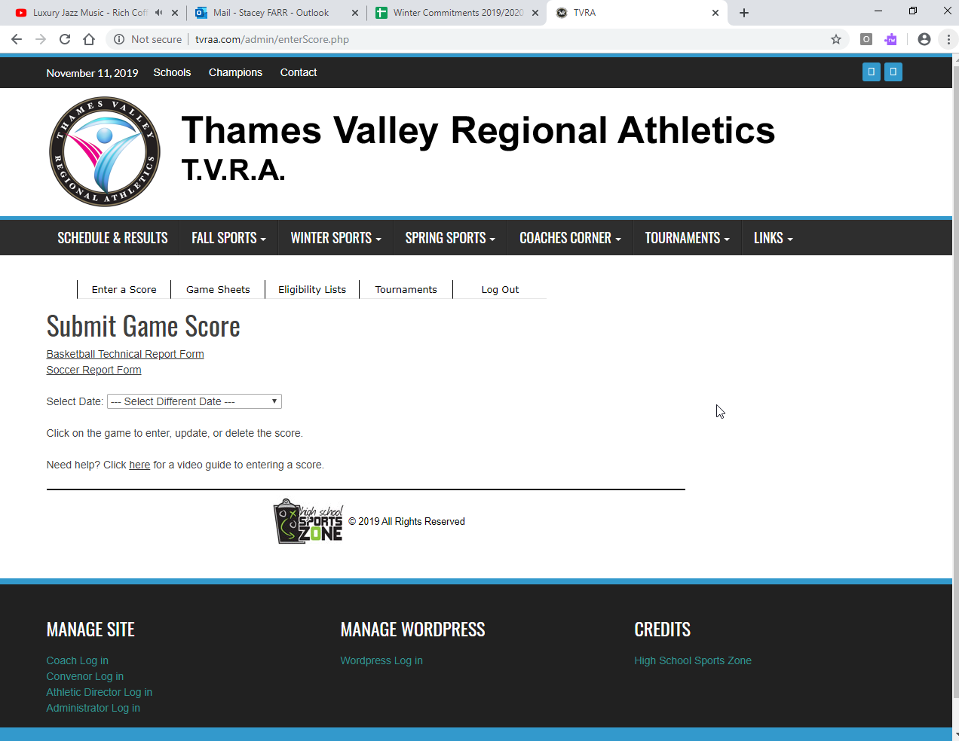
- Ejections
  - Please e-mail me directly if a student-athlete from your team has been ejected. That player will be suspended for the next league game.

- Schedule - Changes to the playing format…
  - Addition of Parkside (AAA) - means there are now 15 teams in league
  - CRSS now a AA school
  - Consistent with Boys Volleyball/
  - Coaches did not like the re-pooling/not knowing schedule beforehand.
  - Bussing
  - Winter season, difficult to repool with weather conditions, make-up games.
  - NOTE: Playing regulations only allow MAX of 13 games

LAST YEAR LEAGUE RESULTS:
* Teams have been broken into 2 Tiers, based on last years combined records, with precedence given to junior when there is a tie.

TEAM | JUNIOR | SENIOR | TOTAL POINTS
Beal | 8 | 8 | 16
Lucas | 9 | 5 | 14
Saunders | 5 | 9 | 14
Laurier | 3 | 6 | 9
Medway | 10 | 6 | 16 *
SDCI | 4 | 10 | 14 *
Oakridge | 5 | 0 | 5
Banting | 0 | 2 | 2
TEAM | JUNIOR | SENIOR | TOTAL POINTS
PCI | New AAA Team joining from South East
Central | 5 | 7 | 13
CRSS | 7 | 4 | 12
NMDHS | 6 | 3 | 9
South | 4 | 3 | 7
West | 0 | 7 | 7
Montcalm | 4 | 0 | 4

TIER 1 |  | TIER 2
A | B | A | B
Beal | Lucas | Parkside | Central
Laurier | Saunders | NMDHS | Clarke Road
Medway | SDCI | South | Westminster
Banting | Oakridge |  | Montcalm

Tier 1 Teams - will play each team in their “pool” 2x (home and away), and then each team in pool B once, for a total of 10 games.

Tier 2 Teams - will play each team in their “pool” 2x (home and away *Note: Central and Westminster only play once), and then each team in pool B once + the additional games (see below).

Clarke Road
Central & Westminster only play once.
PCI Central
NMDHS Westminster
South Montcalm
- The 2 AAA teams in Tier 2, will be ranked 9th and 10th respectively.
- The 2nd and 3rd placed AA teams will play in the semi-finals.
- A will play in the final, as usual.
Note: Preliminary games to be played before exams.
Things to be aware of:
  - Banting Seniors all games at 3:30pm
  - Clarke Road Seniors Monday games @ 3:30

- SCORERS TABLE
  - Please do your best to ensure that you have competent people at the scorer’s table. * The LBBO would be happy to send someone out to train your students if you feel that would be beneficial for you.
  - NO cell phones at the scorer’s table.
  - I have attached a table sheet that might help for further clarification

- Change of game process & forms – must be signed by both schools and submitted to the convener a MINIMUM of 48hrs before the proposed game change.
- Change of Game Process & Forms can be accessed @
- http://tvraa.com/blog/wp-content/uploads/2017/09/Change-of-schedule-procedure-form.pdf
- *Please follow the proper process as indicated in the link above

- TVRA website
- Coaches log in – Speak to your AD if you are unsure of your login & password
- Reporting scores - Home team is responsible for inputting results @ uploading scoresheet IMMEDIATELY after the game.
*Playing Regulation 3.6 When recording the score on the web site for the official standings and tie breaking purposes, the score differential will only be 20 points.

- Eligibility Lists
  - NEW – Eligibility forms now submitted through Coach portal on TVRA Website.

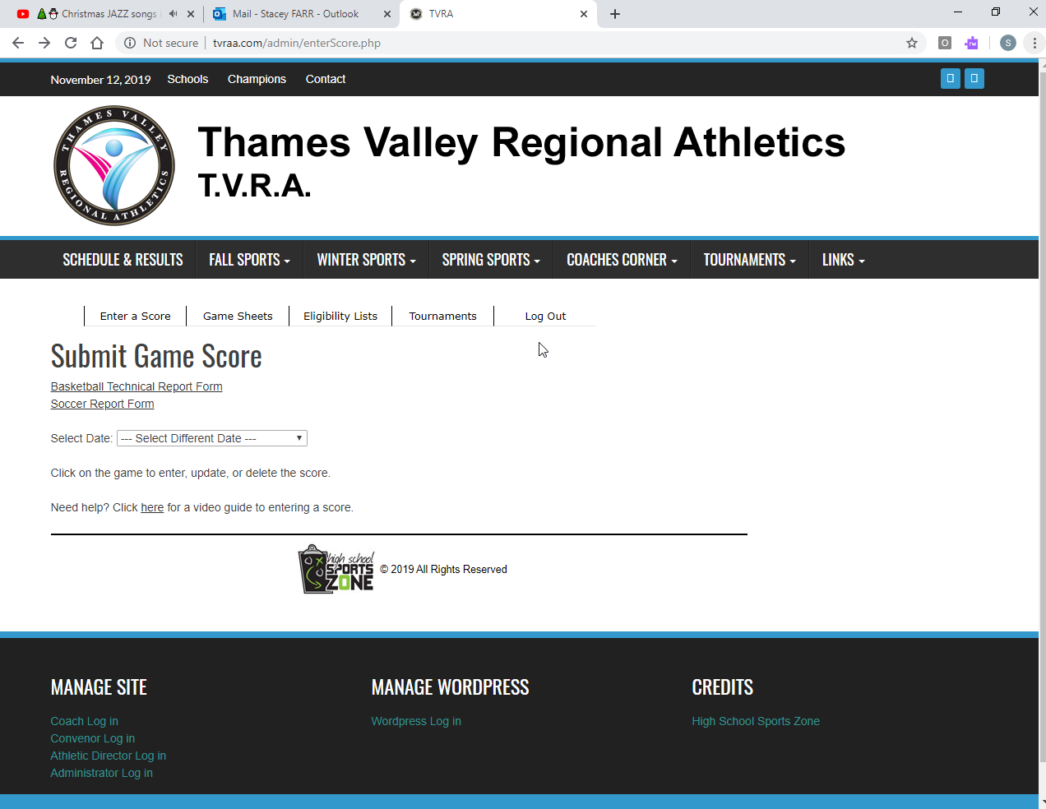

To create your team list…
- Available through Employee Portal > Secondary Sports > Coaches > Team Manager
- Must be submitted a minimum of 24h prior to first game. **This includes exhibition and/or tournaments!!!!
- Don’t forget to include signatures.
- **Do not play transfer students until approved by Michelle Lange

JUNIOR PLAYING SENIOR – a Junior player can play in ONE league game at any time. If they play in a second game, they can no longer play in a junior game.

PLAYOFFS - A junior player can also play in a Senior playoff game as long as they have played in 1 league game – they cannot however, play in both a Jr and Sr game in the same round. (i.e. Juniors lose in quarter finals, a junior player cannot play in the sr quarter final game, but can play in the semi-final game and so on)

- Playoff Format & Sites – Week of February 17th
- TVRA A/AA FINAL @ Fanshawe College
- TVRA AAA FINAL @ Fanshawe College
  - 3pt line will be taped to regulation

- Tournaments
- Do not set up tournaments until you have secured refs.
- Ontario High School Tournaments
  - Website: https://ontariohighschoolbballtournaments.weebly.com/

- Game Sheets
- Available http://tvraa.com/blog/wp-content/uploads/2016/09/basketball-scoresheet.pdf Make sure to check off starters and sign.

- WOSSAA & OFSAA Information
WOSSAA- February 26th
  - Boys A @ HP - JR Champion to HOST/ SR Champion to HOST
  - Boys AA @ Central - JR Champion to HOST/ SR Champion to HOST
  - Boys AAA @ Central - Laurier to Host
- OFSSA – Mar 9 -11
  - Boys A in North Bay
  - Boys AA in Windsor
  - Boys AAA in Burlington
- Awards and All-Star Game - All-Star game to be held at Clarke Road

- LBBCA (London Boys Basketball Coaches Association) – Jamie

- Other Business
- Game Ball – Wilson or Molten?? (Should decide what ball we are using for playoffs)
- City Finals @ Fanshawe. Same ball, same hoop, but different-sized court.
- Check your schedule and make sure that it is correct.
- Start Times – 3:30 & 5 (Can start earlier if referees are there and both coaches agree)
- ??

