TVRA SENIOR
BOYS’ VOLLEYBALL
ALL-STAR GAME

LOCATION: JOHN PAUL II CATHOLIC SECONDARY SCHOOL
THURSDAY, NOVEMBER 15, 2018

Information for the All-Star

Event Timeline
6:00 – Arrival – meet coaches and teammates
6:25 – Team pictures
6:30 – 6:50 – Warm-ups
6:50 – Player introductions
7:00 – 9:00 – All-star game & presentation of Mr. Volleyball award winners

What To Bring
- Volleyball gear
- Black shorts
- Water bottle
- $ 15 – Cash or cheque (cheques can be made payable to “John Paul II Catholic Secondary School”)
- Each all-star will receive a t-shirt uniform to keep

What To Expect
- Every player will play at least one set. However, some players will play more. There are 30 all-stars!
- The game is meant to highlight the talented volleyball programs in TVRA.
- Positive attitudes and sportsmanship are expected. Remember, you are an ambassador for your school.
- Each team will have a mix of players from TVDSB Central, TVDSB Southeast, and London District Association.
- During the match, the nominees for Mr. Volleyball will be recognized and the winners will be announced.
- Each team will have a head coach who is a former Canadian national and professional volleyball player. It will be “Team Duerden” vs. “Team Brinkman”.
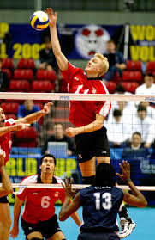
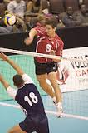
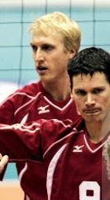
Paul Duerden has lived the volleyball dream. Selected to the National Team directly from high school, Paul trained to the limit everyday, and reaped the rewards by being called the best player in the world. Along with starring for Canada for 16 years, Duerden, an opposite hitter, enjoyed a brilliant professional career in Europe, playing in France, Germany, Belgium, Italy, and Turkey. In his 14 years as a professional, Paul was able to win all 4 European Cups (named MVP in 3 of them) including the most prestigious of them all, the Champions League. Paul can be heard as an analyst with CBC Sports. In June 2018, Paul was inducted into Volleyball Canada’s Hall of Fame. Paul lives in London with his family.

Steve Brinkman was a mainstay on the Canadian national senior men's team for 17 years, backstopping a powerhouse squad world-renowned for its blocking prowess. A teammate of London's own Paul Duerden, Steve competed in over 300 international matches for Canada. Brinkman, a middle attacker/blocker, also enjoyed a lengthy professional volleyball career, competing around the world, including in France, Italy, China and Russia, and winning both the prestigious World Club Championship and European Cup Championship. Steve and his family live in London.

THANK YOU TO STEVE AND PAUL FOR THEIR PARTICIPATION!

Information for Coaches, Parents, Teammates, and Friends
- Invite your family, friends, high school teammates, club teammates, teachers, and coaches to watch you play.
- Gym doors for fans will open at 6:30. Remember, player introductions begin at 6:50.
- The event is free.

Questions?
- If you have questions or need further explanation, contact Mr. Frank Delle Donne at John Paul II Catholic Secondary School – fdelledonne@ldcsb.ca or 519-675-4432

